

**Assignment 2: The IT World**

**Lecturer: Dr. Long Nguyen**

**Team name: Group 23**

**Team members:**

* **Cao Ngoc Son - s3916151**
* **Doan Chanh Thong- s3852304**
* **Le Thanh Tai – s3760615**
* **Nguyen Tan Thinh - *s3927186***

**Date of submission: 19 December 2021**

I declare that in submitting all work for this assessment I have read, understood and agree to the content and expectations of the Assessment declaration

Table of Contents

**I.** **Team profile** 3

**1.1** **Team name** 3

**1.2** **Personal information** 3

**1.3** **Team profile** 4

**1.4** **Ideal job** 12

**II.** **Tools** 13

**III.** **IT Work** 14

**IV.** **IT Technologies** 15

**Artificial Intelligence and Machine Learning** 15

**Autonomous vehicles** 20

**Cloud computing** 24

**V.** **Project Ideas** 31

**a.** **Overview** 31

**b.** **Motivation** 31

**c.** **Features** 31

**d.** **UI Design** 32

**e.** **Diagrams** 37

**f.** **Tools and Technologies** 39

**g.** **Skills Required** 39

**h.** **Outcome** 39

**VI.** **Feedback** 39

**VII.** **References** 40

1. **Team profile**
   1. **Team name**

After consideration, our team decided to name the group project “Group 23”. The main reason is that none of us could think of a good name for the team and assumed that the name was not that important. So, we came up with “Group 23” just like the number of our group on Canvas to make it easy to remember.

* 1. **Personal information**

**Nguyen Tan Thinh**

My name is Nguyen Tan Thinh (s3927186), I was born and raised in Ho Chi Minh City in Viet Nam. I have been a student with 12 years of outstanding academic performance, a 7.0 IELTS score, and completion in math, chemistry, and computer science A-level courses. Besides my mother tongue, I can speak fluent English. As for hobbies, I really like PCs (personal computers), cars, motorcycles, and I especially have a lot of love for animals. I enjoyed coding because to me it is one of the most interesting aspects of computing. As mentioned, I have completed an A-level computer science course, so I have been coding with Python for 2 years.

**Le Thanh Tai**

I am Le Thanh Tai and I am a third-year student of RMIT University. My major is Software Engineering. I was born in Da Nang and moved to Ho Chi Minh City when I was 2. I can use both Vietnamese and English. I can also use some of the programming languages like C, C++ and Java. I do have some hobbies and one of them is photography. Though I am into photography and also have taken a class called Photography 101 from RMIT, my skill in taking photos is decent and needs more practicing. I also love pets, especially the ones with fur like cats and dogs. I do have a cat, which I adopted a year ago when I found it on the street.

**Doan Chanh Thong**

My name is Doan Chanh Thong, and my student ID is s3852304. I am a Vietnamese who study in RMIT SGS, but currently in online mode. I am interested in basketball and the field of IT, especially Artificial Intelligence. I usually spend most of my time on the computer, searching for anything related to Technology. Recently, I have invested in cryptocurrency after hours of researching, following the news, and gaining knowledge from Fintech RMIT club and workshop. However, the profit has not come yet, but I have broadened my knowledge of this topic. I am never bored learning and doing things about IT.

To be honest, I don't have much experience in IT area. After finishing high school, I started many projects with Python and C# after self-studying; however, it was a long time ago, and I did not obtain any specific achievement. But I am willing to learn and embrace the difficulties, and my weaknesses to improve further in the university environment and future career. My current skills are calculus and linear algebra, analytical skills, and knowledge and experience about C# and Python.

**Cao Ngoc Son**

My name is Cao Ngoc Son(s3916151) and I am a first-year student at RMIT SGS. I studied high school abroad at Western Reserve Academy, Ohio, USA for 3 years and started at RMIT this July. During my high schools days, I focused on learning computer science and coding-related course. Coming into this second semester, I have 2 years of Python experience, 1 year of Java under my belt, and basic understanding of HTML and CSS. I have also learned AP computer science, AP Statistics, and Calculus. I have been especially interested in developing software and looking forward to learning to become a fully fledge software developer. Aside from that, my hobbies include reading novels, comics and watching films.

* 1. **Team profile**

**Nguyen Tan Thinh**

**MBIT Test**

Link: <https://www.16personalities.com/istp-personality>

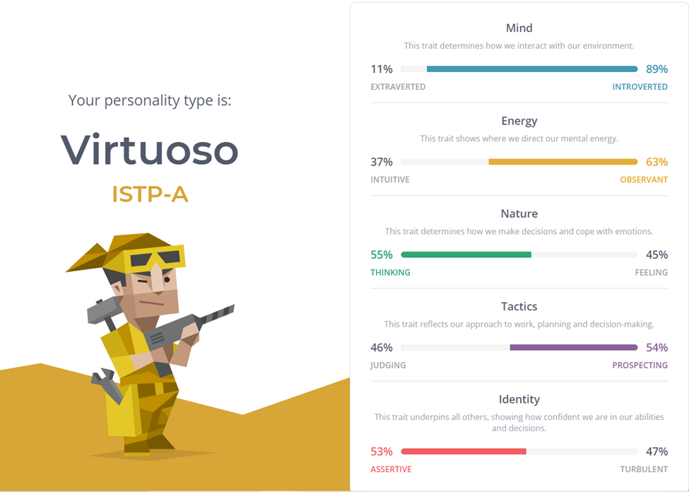

**Learning style test**

Link: <http://www.educationplanner.org/students/self-assessments/learning-styles-quiz.shtml?event=results&A=7&V=7&T=6>

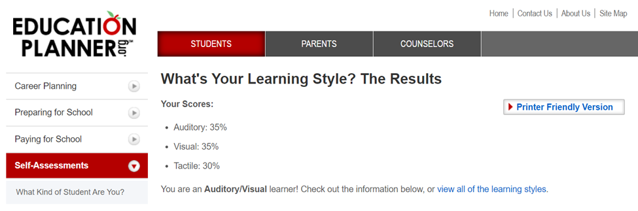

**Team role test**

Link: <https://www.123test.com/team-roles-test/id=BVTNETIRXXDN&version=>

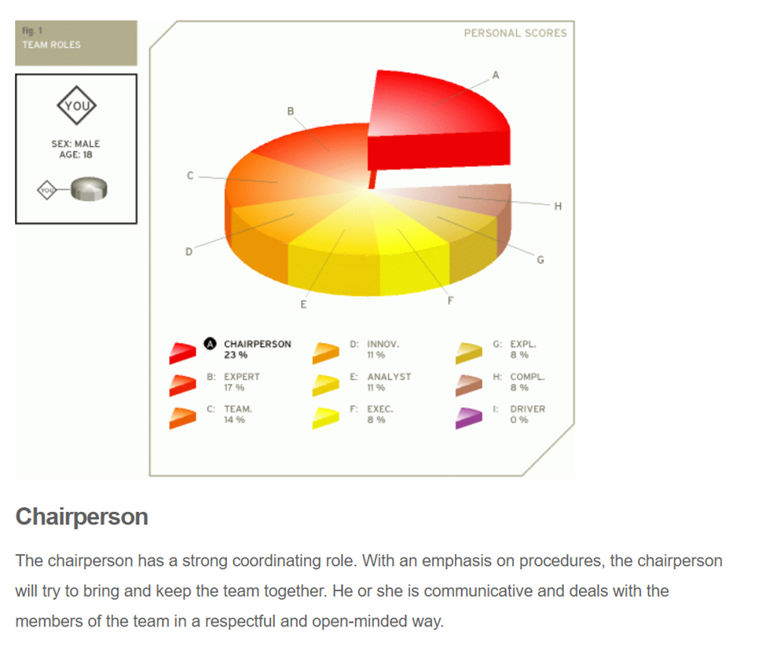

I agreed that the results of these tests do represent in some angle from a person’s personality and the way they act; however, they can’t be used to assume that person’s characteristic completely. As mentioned above, these tests results do reflect and highlight a person’s personality traits since they are the ones who answer the questions using their own mind and thought. When looking at the results, that person can know what their strengths and weaknesses are, so they can improve to be better than their past self. In contrast, these results shouldn’t be relied on completely, especially in the long run because people change, some get better, some get worse. In conclusion, people should view these tests as an indication of what their personality is at that time and try to figure out what is best for them or what to change to improve themselves.

**Le Thanh Tai**

**MBIT Test**

Link: https://www.16personalities.com/free-personality-test

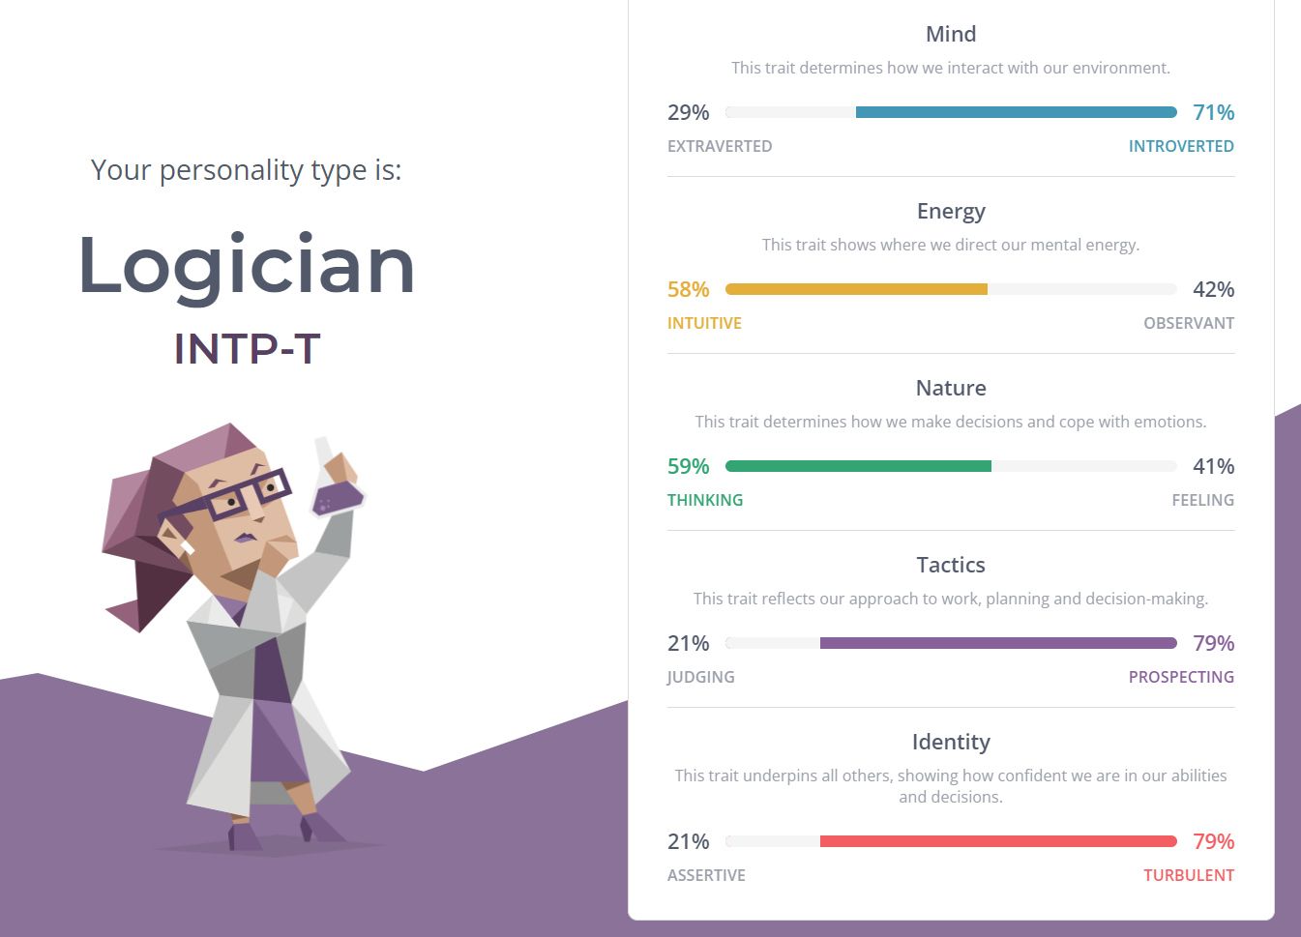

**Leaning style test**

Link: http://www.educationplanner.org/students/self-assessments/learning-styles-quiz.shtml

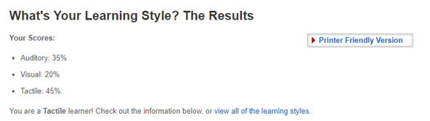

**Big five personality test**

Link: https://www.truity.com/test/big-five-personality-test

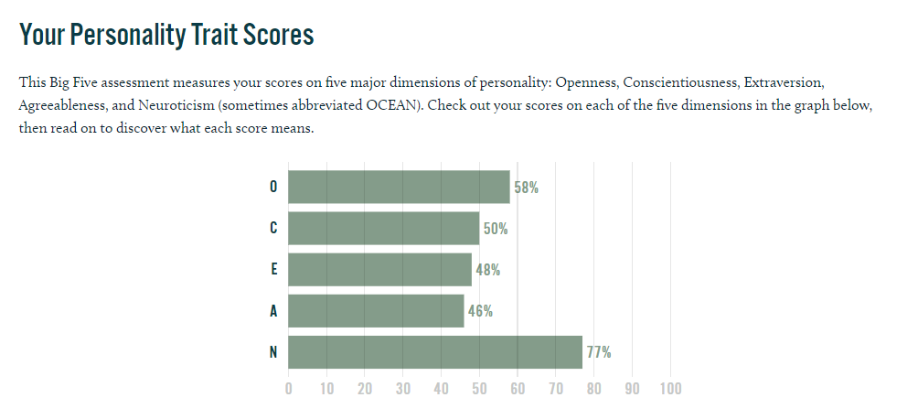

To be honest, I do not believe much in the tests about personality though many of them I considered correct to me. But these tests are kind of interesting, and I can use these as materials to make comments on myself and figure out how I should be like. Considered working in a team, with those academic tests achieved, I can use them as evidence to show other members my abilities. And to be considered as a Logician in the MBIT test, I feel more confident to stand out in the team.

**Doan Chanh Thong**

#### **The results of an online Myers-Briggs test**

#### Link: (<https://www.16personalities.com/enfj-personality>):

-> a protagonist person (love helping others, and they tend to have strong ideas and values. Back their perspective with the creative energy to achieve goals.)

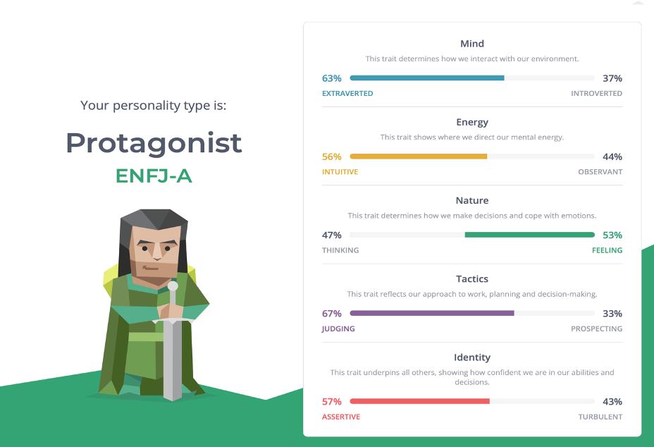

**The results of an online learning style test**

Link: (<http://www.educationplanner.org/students/self-assessments/learning-styles-quiz.shtml?event=results&A=7&V=5&T=8>)

-> A Tactile learner (learn by touching and doing)

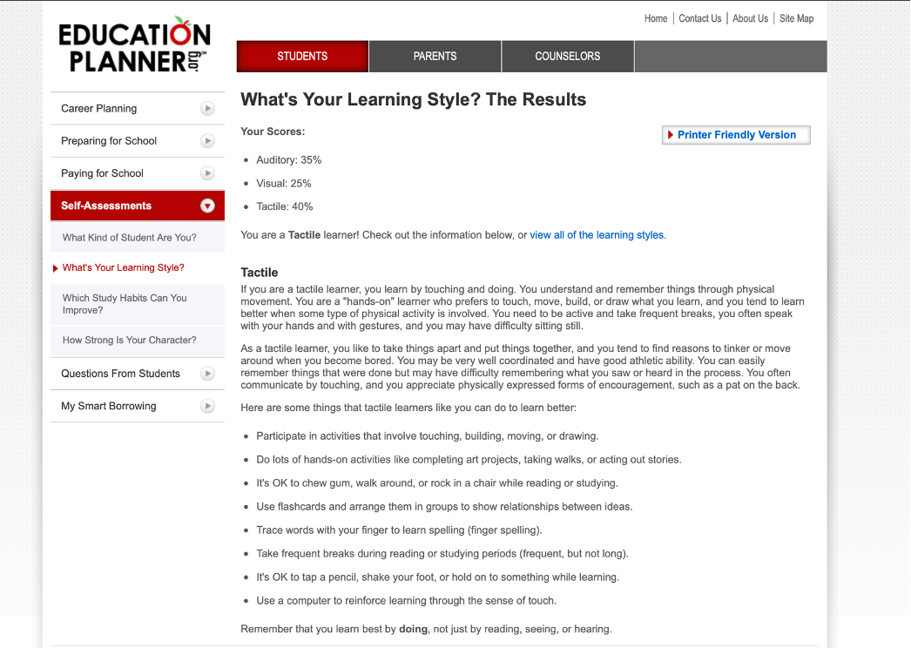

**The result of analytical skill online test**

Link: (<https://www.3smartcubes.com/pages/tests/analytical-skills-test/analytical-skills-test_report/>):

-> 11/12 analytical skill

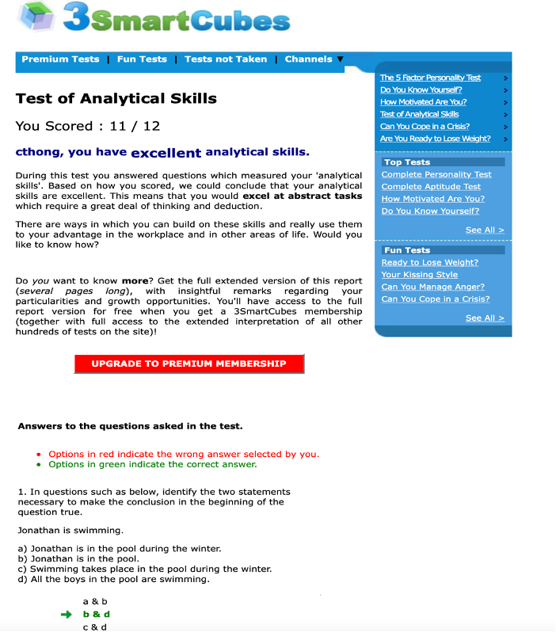

* These above test results are partly true and genuinely prove me a friendly person who can collaborate with a team through effective communication, solve conflicts and persuade people to work on the right track. In addition, they are significant influences on my behavior for the team whenever there are arguments. However, if there is a new technical problem, I would need time to figure it out and tangibly execute it after hands-on practice. Therefore, it reflects who I genuinely am and how I can work with the team.
* I believe my behavior will not affect the team because I am a great listener and open-minded person that can communicate with my team and give them the solutions for any conflict, which was proved by the test. Moreover, when it comes to projects that require technical problems, I could discuss with high theoretical ideas and analytical aspects to help the team solve the case. The benefits we mutually bring for each other give us the energy to complete any task eventually. I believe the team will be happy to accept me as a member.

**Cao Ngoc Son**

**Myers-Briggs’s test result**

Link: https://www.16personalities.com/intp-personality

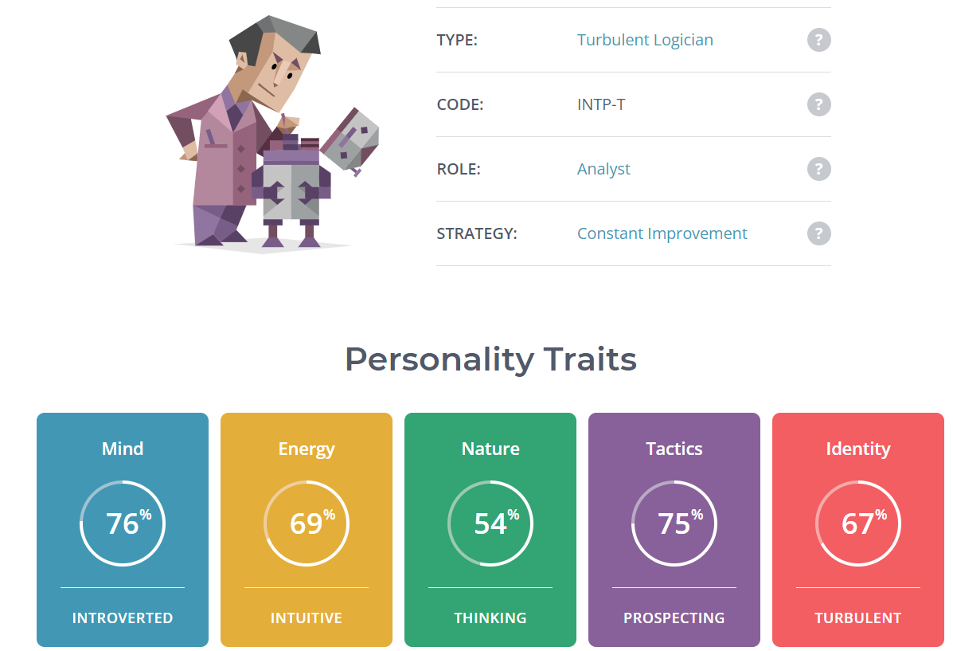

**Online Learning Style Test**

Link: https://personalitymax.com/report/?ls=64-49-69&name_key=2c0dc87973

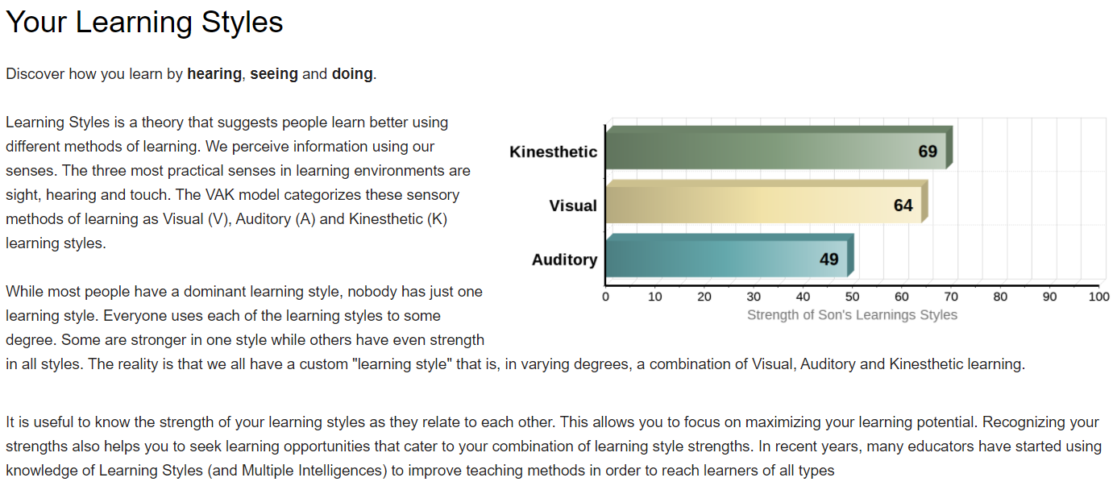

**Big Five Personality Test**

Link: <https://www.truity.com/test/big-five-personality-test>

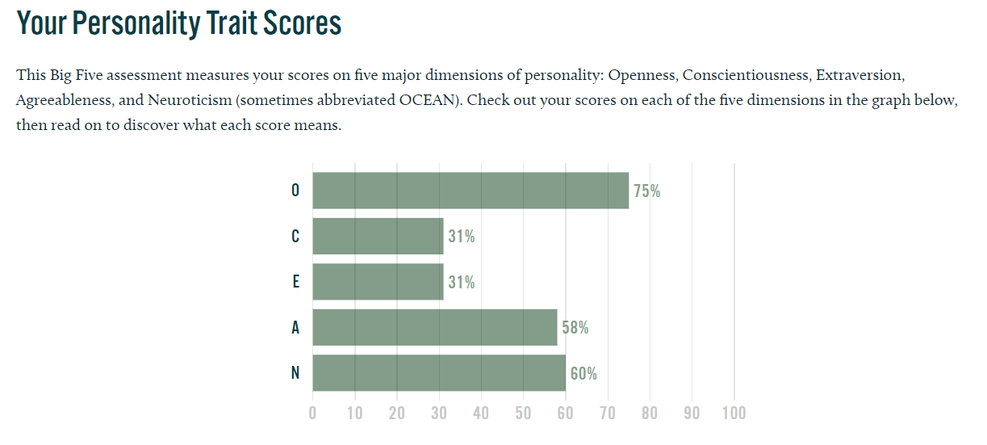

These results demonstrated who I am and helped to define how I work. Some of my strengths are that I am unique, open-minded, curious, and very inventive. One of my biggest assets that may aid the team is my ability to adjust to changing situations and be very adaptable. The three tests reveal some major flaws that have previously hampered my efforts. Such flaws have resulted in issues such as my detachment from others, being a perfectionist, or being easily distracted. However, I feel that such issues will not significantly impede the team because other members of the group can assist in rectifying my shortcomings.

* 1. **Ideal job**

**Nguyen Tan Thinh**

My ideal job is to become a senior Python Developer and the job is to tackle software development tasks in Python languages. The job required me to be able to design, test, improve, and maintain internal and external software systems. It also required me to participate in code reviews of my own and other developers' code as well as mentor junior developers and provide coaching to them.

**Le Thanh Tai**

In my point of view, Java is very interesting, and I love the Object-Oriented Programming. Therefore, I am seeking for a job as a Java Developer. But later on, I want to get a PHD and work as a university lecturer in my 40s.

**Doan Chanh Thong**

My ideal job would be a full-time Quantitative/Data Science Analyst. Working with data and participating in Fintech area is what I find intriguing and fascinating, this position would be ideally for me. I’d love to examine blockchain data in-depth and perform Defi protocol mathematical derivations to evaluate and propose database and analytics management strategies for the company.

**Cao Ngoc Son**

Although it differs from the other members of my group, my desired employment is being a software developer. Ideally, I would like to create something from scratch and collaborate with others in order to learn from them and increase my skill set. What I'm looking for in a work is the ability to participate in the creation of anything from the beginning, as well as the delight of developing and overseeing what you built with your own hands. This position will necessitate a wide range of abilities, including but not limited to front-end/back-end development, experience with IoT edge-related technologies, software, and knowledge of many common programming languages. When I have enough experience, my professional goal is to progress from participating in an IoT project to creating and directing my own IoT project.

**Comparison:**

Here's the contrast after reading and comprehending each member's desired work. In general, our professions are comparable in terms of designing, dealing with data, and problem solving. Aside from that, each of our jobs has certain distinguishing features that set us apart from one another. Thinh's job is to deal with Python software development tasks; Tai's job is to develop applications and software using the Java programming language; Thong's job is to design, run, and maintain data systems and databases; and Son's job is to design and develop software systems that meet the client's requirements. While Thong, Thinh, and Son tend to stay in their department for as long as they can, Tai hopes to go from Java Developer to university lecturer later in life.

1. **Tools**

Link: <https://github.com/s3927186/Assignment2.git>

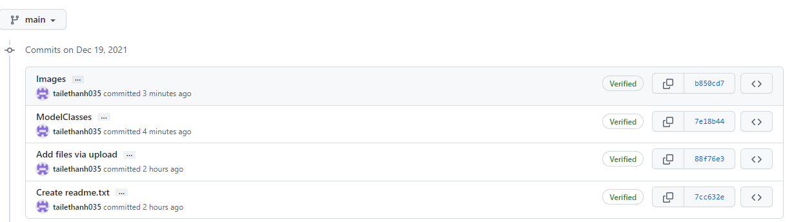

By checking the commit history on our Git repository, we can see what the team members have done. Git Hub has provided a convenient tool for us to share the project folder with each other and then each of us can work on our own and then commit our work to our group’s repository. By using this way, not only we can access storage sharing between the whole group but we can also check progress of the team and what each member has done during the project. Though we do not have many files in our repository cause we have just come up with the idea and still been working on it, but after couple of commits from the team members, we can see that Git help us in many fields of the project including teamwork, progress management, data storage and so on. As a result, all of our team members agree that Git Hub will definitely be necessary in our every project from now on.

1. **IT Work**

**Interviewee:** Le Thanh Dat

**Company:** Marvell Technology Group (5th Floor, Block B Incubation Center Building, Lot D.01. Tan Thuan Road, Tan Thuan Export Processing Zone Tan Thuan Dong Ward, District 7. Ho Chi Minh City.)

**Years of experience**: 3 years (graduated from Back Khoa – HCMC University of Technology in 2018, started working since then)

***Questions:***

1. ***Please tell us about your IT work. What exactly do you do? ‘***

I am synthesis engineer. The designer will give me a RTL design and I have to transform it to gate netlist design, then optimize it to match the target of design (speed, power, area). Then I have to check the function of two design are equivalent.

1. ***Please tell us about the industry you work in.***

I work in semiconductor industry. This industry designs and manufacture chips ( example 5G chip, computer chip ...)

1. ***What other kinds of work do you have to do?***

Sometimes I have to generate scripts to collect and summarize data (reports) to analyze issue or quality of design

1. ***Who are all the different people you interact with in your work? Please tell us about***   
   ***them. Please tell us about your interactions with other IT professionals.***

I communicate with the designer when there is something wrong with the RTL design, or the target, constraint is too strictly that the design cannot meet the target. The designer is a person communicate clients to design the chip according to descriptions of client

1. ***What about your interactions with clients or investors?***

No, I don't communicate with client or investors. The designers will communicate directly with the clients.

1. ***What aspects of your work do you spend most time on? Please tell us about these.***

Synthesizing usually takes the most time of me. I have to set up the environment, the standard cell library and script to run synthesis. And after synthesizing finish, I have to check if the design violates given constraints.

1. ***Which aspects of your work do you find most challenging?***

I think the most challenging in my work is timing check. Because sometimes after synthesizing, the design has million violations, you have to analyzing them and fix them.

1. ***Finally, can you share an example of the work you do that best captures the essence of***  
   ***the IT industry?***

For example, I write script to use implementation tool in order to synthesize and check function of designs

1. **IT Technologies**

## **Artificial Intelligence and Machine Learning**

***1.What does it do?***

With the continuous advancement of science and technologies in the modern world, computers have changed human life dramatically. Artificial Intelligence is one of the technologies that will create significant impacts and involve almost every aspect of our life in the future. For its definition, according to Caiming Zhang and Yang Lu (2021) [1], AI simulates human intelligent behaviors with computers and trains computers to learn human behaviors such as learning, judgment, and decision-making.[3] [8] As for its form, artificial intelligence is a field that combines computer science and large datasets to solve problems. It also includes the subfields of machine learning and deep learning. AI algorithms are used in these disciplines to create expert systems that make predictions or classifications based on input data.

While there are multiple definitions of the term "Artificial Intelligence," its notion was first proposed at the Dartmouth Conference in 1956 and brought in the 2004 paper by John McCarthy [4]. He defines: "It is the science and engineering of making intelligent machines, especially intelligent computer programs. It is related to the similar task of using computers to understand human intelligence, but AI does not have to confine itself to methods that are biologically observable." However, the birth of the AI debate was marked decades before this definition by Alan Turing's seminal work, "Computing Machinery and Intelligence," published in 1950. Turing, known as the "Father of Computer Science," poses the question, "Can machines think?" in this paper. From there, he proposes the "Turing Test," in which a human interrogator attempts to distinguish between a computer and a human text response. While this test has been heavily scrutinized since its publication, it remains an essential part of the history of AI and an ongoing concept within philosophy due to its linguistic ideas. Stuart Russell and Peter Norvig (2021) then published Artificial Intelligence: A Modern Approach [5], which dives deep into four potential AI approaches or meanings, distinguishing computer systems based on rationality and thinking vs. acting: [4]

1. Thinking humanly

2. Thinking rationally

3. Acting humanly

4. Acting rationally

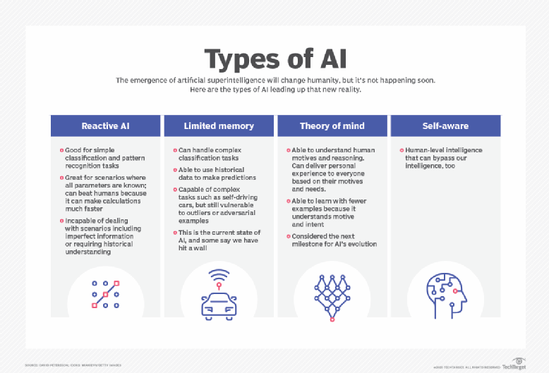

Besides, artificial intelligence is classified into two types based on capabilities and functionalities. For its functionalities, according to Arend Hintze (2016) [6] [7], there are four types of AI:

1. **Reactive Machines**: These machines are the basic types of AI, focus only on current situations, and do not store memories for future actions. IBM's deep blue system and Google's Alpha go are the examples of reactive machines.
2. **Limited Memory**: These machines can store data or past memories for a short period. Examples are self-driving cars. They can store information to navigate the road, speed, and distance of nearby cars.
3. **Theory of Mind**: These systems understand emotions, beliefs, and requirements like humans. These machines are still not invented, and it is a long-term goal for researchers to create.
4. **Self-Awareness**: Self-awareness AI is the future of artificial intelligence. These machines can outsmart humans. If these machines are invented, they can revolutionize human society.

AI is categorized as either strong or weak toward its capabilities, reported by the TechTarget (2021) website.[7]

* Weak AI, also known as narrow AI, is an AI system that is designed and trained to complete a specific task. Self-driving cars, IBM's Watson supercomputer, and virtual assistants, such as Apple's Siri, use weak AI.
* Strong AI (AGI), an artificial general intelligence system, performs nearly every cognitive task as efficiently as humans can do. When it comes to unfamiliar tasks, the system will apply knowledge from one domain to another and find a solution autonomously. Theoretically, a Strong AI system can pass the Turing and Chinese room tests.

In the meantime, AI can be identified as two main capabilities: Weak AI and General AI (Strong AI). In addition, there have been significant achievements of AI in recent years. Artificial intelligence can outperform human cognition in analyzing, diagnosing, and complicating complex medical data in the health care sector. For instance, IBM Watson is well-known healthcare technology.[7] Other AI applications include using chatbots and online virtual health assistants to assist patients and healthcare customers in locating medical information, scheduling appointments, understanding the billing process, and completing other administrative tasks. AI technologies are also being used to predict, fight, and understand pandemics like COVID-19. With these current advancements, it is predicted that AI will drive the personalized medicine revolution in the coming years, from diagnosing brain tumors to determining which cancer treatment will be most effective for an individual.[2] In terms of transportation, besides autonomous cars made by Google in 2014 [3] and transportations like driverless Boeing and autonomous train, AI technologies are used to manage traffic, predict flight delays, and make ocean shipping safer and more efficient [7]. By 2030, it is forecast that self-driving cars and autonomous transportations will be ubiquitous.[2]

***2.What is the likely impact?***

The improvement in technology (Artificial Intelligence) has indeed revolutionized our lives. However, Artificial Intelligence will positively and negatively affect society as it continually transforms the world. This section will analyze several benefits of AI as well as its upcoming challenges toward our society. One of the most noticeable benefits is that AI has significantly enhanced the level of productivity as well as the efficiencies in workplaces. [9] [10]Thanks to the AI robot, humans are happier and more enjoyable of their work because AI now does repetitive works or dangerous tasks that reduce human errors and spare humans from risky tasks like exploring the farthest place on earth or the deepest part of the ocean. Ultimately, it frees up the human workforce, who could now focus on what matters. According to an Accenture study, artificial intelligence can increase productivity by 40% and profitability by 38% on average[12]. Furthermore, AI also improves the operations of healthcare facilities. The diagnostic and monitoring capabilities are becoming better, and AI has dramatically influenced healthcare by reducing operating costs and saving money. According to one McKinsey estimate, big data could save medicine and pharma up to $100 billion per year [11]. In contrast to these, the emergence of AI concurrently brings some challenges for society. One of the main concerns is the unemployment level, the loss of jobs to machines. However, it is just the explicit, and the real challenge is that people will have to adapt to the new trend and find their way to a more complex and administrative role, which is their unique abilities. According to PricewaterhouseCoopers, AI will replace 7 million existing jobs in the UK between 2017 and 2037, but 7.2 million new jobs could be created[13]. This poses a difficult challenge for people making their living, requiring people to be creative and always renew themself to keep up with the new trend so that machines could not eliminate them in the future.

***3.How will this affect you?***

With the development of science and technologies, AI has undoubtedly provided people with significant impacts both on benefits and difficulties. In my perspective, this technology has brought many innovations to our lives and become an indispensable part of every life aspect. In fact, it has an enormous impact on our decision and lifestyle every day. A prominent example of this is Google search. An essential tool used to search any sort of thing and run with Artificial Intelligence that can recommend related ideas, videos, or information based on the search query. I always use Google search to look for any kind of information every day, and it is beneficial toward my education and entertainment. For instance, it is easy for me to surf the internet and find information to learn as much as I can for a particular topic like programming and dive deep into the knowledge with the help of AI. Alternatively, when I use Netflix, the AI recommends the content that best fits my preference and comforts me with the enjoyable moment. Moreover, the faceID on iPhone uses machine learning algorithms( sub-field of AI) to compare the scan of your face to what it has stored about your face to determine whether the person attempting to unlock is the owner. This is beneficial when it comes to phone security, preventing strangers from accessing my phone. The protection is strong and guaranteed. Overall, AI has enhanced personal life in many ways, and it is the future for humankind. The emergence of modern technologies utilizing AI will become ubiquitous as AI will make human life much more comfortable by providing solutions to almost every problem claimed by experts. Likewise, AI will open up opportunities for many domains such as education, transportation, entertainment, healthcare. People would be intriguing, delightful, embrace, and quickly adapt to the differences brought by AI.

**Autonomous vehicles**

* **The state of the technology:**

Nowadays as the technology is getting more advanced, many aspects of the world have been improved such as VR/AR systems for entertainment, robots for industrial production, and the aspect that we can see the clearest changes in recent years are transportation with the increased number of autonomous cars. An autonomous vehicle is a vehicle that is capable of sensing its surroundings and operating by itself without any human interaction. The autonomous vehicle can be divided into six different levels:

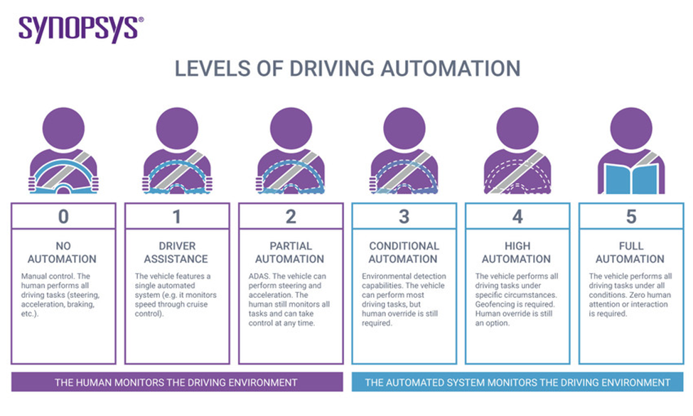

*Six level of driving automation* [14]

Level 0 is no automation means the driver performs all of the driving tasks, this level can be seen in mainly old generation vehicles or as a mode in many sports cars. Level 1 is driver assistance which some driver-assisted features are included like cruise control, traction control, this level is set as a standard for the current-generation vehicles. Level 2 is partial automation where ADAS (advanced driver-assistance systems) can control the car steering and acceleration but human still need to monitor all tasks. Level 3 is conditional automation, at this level the vehicle can perform most driving tasks but human override is still required, this level is where the state of autonomous technology for the current generation of cars is at, and it can be seen and set as a standard for all Tesla’s model. Level 4 is high automation which is similar to level 3 but human override has become an option, this level is where many car manufacturers are aiming at in the near future which can be seen in many cars concept designs from many different car manufacturers for example BMW Vision next 100 from BMW, Toyota Concept-i from Toyota, Peugeot e-Legend from Peugeot, etc. Lastly is Level 5, full automation is where the car industry strives for in the future which zeroes human attention or interaction is required, this can also be seen through many concept designs from many car brands like Audi with Audi Aicon, Rolls-Royce with Rolls-Royce 103EX, etc.

Right now, many large car companies are still competing and creating more advanced and high-tech models each year such as switching to electric models and updating their information system with lots of features and modes. However, they are only creating and improving their products at level 2 automation, there’s not much competition at level 3 automation. While Tesla constantly updated their AI for autopilot mode to hopefully perfection so they can start testing on level 4 automation, other brands such as BMW, Honda, Mercedes are only at the testing stage or updating their system trying to catch up to Tesla, but this still shows some promising future for self-driving vehicles. At this rate, people will start to see a lot of level 3 autonomous self-driving vehicles from various brands in the next 5 years, but level 4 automation is still a question.

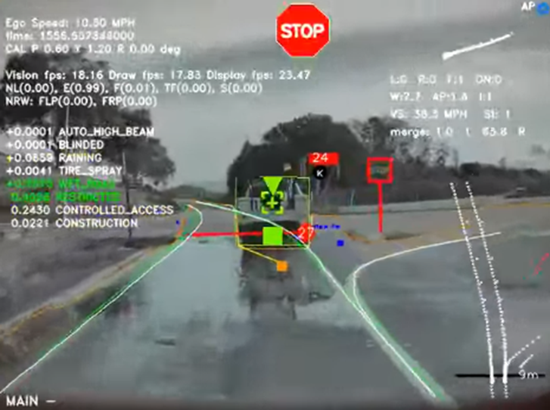

*Tesla Autopilot neural networks* [16]

To be able to create a vehicle that can drive itself, a number of advanced technological developments are needed to make this possible. Tesla technologies will be used as references to demonstrate how an autonomous vehicle works. There are up to 8 surround cameras and 12 ultrasonic sensors are attached around the car, allowing for detection of both hard and soft objects for 8m [15]. An AI (Artificial Intelligence) chip called Full Self-Driving chip (FSD Chip) is used to sense the environment, control, and operate the car. Plus, to make the AI learn faster and work more efficiently, a system known as Dojo System contains a Dojo Chip with high-level software APIs meant to train the AI, creating an advanced machine learning system [16]. A neural networks system is also needed to train deep neural networks on problems ranging from perception to control.

* **The Impact:**

The autonomous vehicle is a goal that the automotive industry wants to aim for in the future as they are not just possible, but definitely revolutionize the way people travel, live, and work, and they are only stepping closer and closer to this phase. The first impact autonomous vehicles created is they will influence where people choose to live as it is in a report on trends in US real estate in 2017 [17]. With autonomous vehicles, the traffic will be less hectic in a big city environment since the time usually spent driving can be replaced with other activities like working, studying, or just simply relaxing, making people feel more comfortable living in a city. Autonomous cars can also affect immensely on elderly, disabled because they don’t have to drive anymore, hence making their life easier and more flexible in choosing a place to stay. Secondly, driverless vehicles can have an impact on businesses. As mentioned before, autonomous cars will impact people living arrangements, this generates more time for productive activities rather than for example a 30-minute drive to work, making work far more effective than what people are doing now. Another huge impact that self-driving cars can directly affect people's life is road accidents. Each year, it is estimated that about 1.35 million people lose their life on the road around the world [18], and the cause of these accidents mainly are due to human mistakes, this doesn’t happen in a driverless car since they can sense their surroundings, pedestrians, traffic lanes, other cars, and many more at the same time to operate efficiently, which will significantly reduce road accidents. In contrast, there’re still some consequences of self-driving cars, the obvious one is the unemployment of bus and taxi drivers. According to the U.S. Bureau of Labor Statistics, in 2020 taxi and delivery drivers account for 872,600 jobs [19], so when vehicles start driving by themselves, this will become a big problem that is needed to be solved. One more problem is when there’s a high-tech car that can drive by itself is also means there’re opportunities for hackers to try and breach the security of the car.

* **How will this affect us:**

This is unlikely to happen anytime soon since a fully autonomous vehicle will be hard to be available for everyone and the price will be very expensive to afford, so this will not affect a lot to me or my family. However, if in the future autonomous vehicle become standard transportation for everybody, it will definitely change the way how I live and travel every day and it will be the same with people around me. The first difference it can make is how I operate things around me, without the need to drive the vehicle, it allowed me to do more work during the trip from my home to the workplace, making the workflow more effective and breathable. Also, when I no longer need to drive, I can relax and do things that are considered illegal now such as drinking, using my phone, watching movies or even playing games. Secondly, learning to drive and getting a license is no longer needed, additionally, I don’t even need to learn the traffic laws since the vehicle can handle all the driver tasks including speed limit, traffic light, traffic sign command, and so more. Therefore, the chances of getting pulled in by the police are zero, so the autonomous vehicle will make my life easier. Thirdly, one feature that autonomous vehicles provided that is very helpful to me, my family and friends are traveling to a new location for a holiday or special occasions, the autonomous vehicle can access the desired location through Google Maps and take us there without me have to remember the way and look for it which save a lot of time and very convenient. Still, autonomous vehicles can affect me negatively in some situations, when I am late for a meeting or an event, I can’t drive or tell the car to go any faster since it can only go up to the speed limit. But other than that, autonomous vehicles will mostly make a positive difference for me and I am sure they will affect my family and friends the same way.

## **Cloud computing**

**What does it do?**

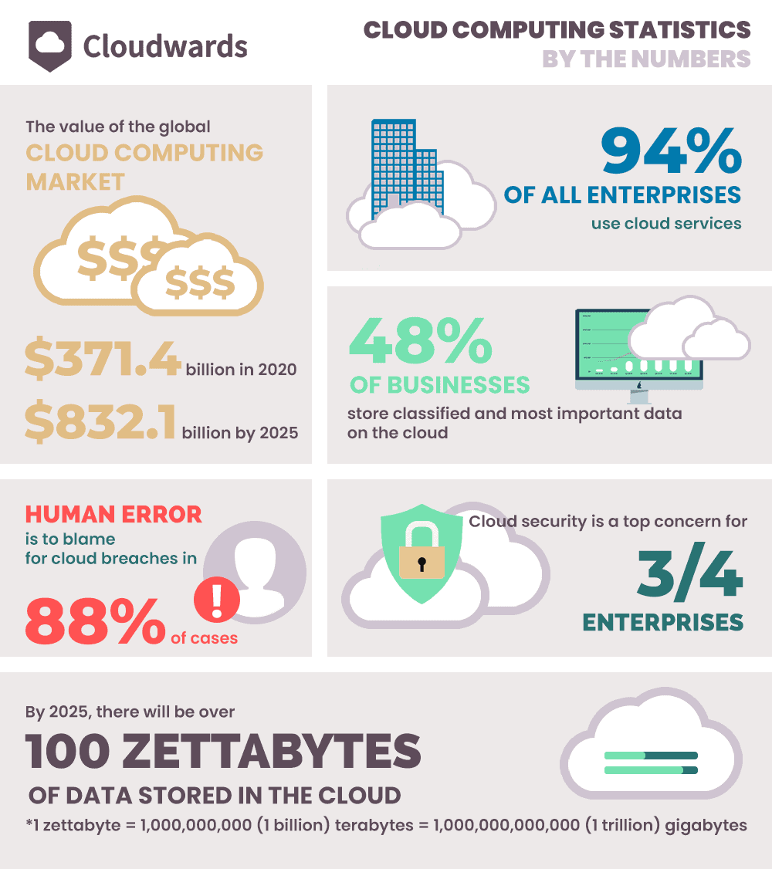

*Cloud computing statistics*[27]

According to Microsoft, Cloud Computing is defined as the technology that provide the computing services via the internet, or the “Cloud”[20]. The term “cloud computing” was invented in 1996 but the idea has been developed since 1950s [21]. There are 3 main types of cloud computing [22]:

* Public cloud: Operated and owned by third-party provider and the most popular. Storage Service like One Drive or Google Cloud are this type.
* Private cloud: Owned and maintained by only one organization.
* Hybrid cloud: Combine the advantages of the 2 types.

The cloud market has turned big and popular in the recent years. For companies and organizations, we can see that in 2020, the global cloud computing market is valued at $371.4 billion but the number is estimated to rise up to $832.1 billion in 2025 [23]. So far, 94 percent of all enterprise is using cloud services in one form or another [24]. And for daily life, it can be said that roughly half of the people in the world have used some form of the cloud computing [25]. Cloud computing has been the backbone of many popular applications in every life like social media like Facebook, Instagram or kinds of video and music streaming services like Netflix and Spotify. As a matter of fact, companies tend to stop providing their services in traditional way but change to the cloud-based services, for example, Disney stop broadcasting their channels on television but streaming it on their Disney Plus Application instead. By the end of 2021, statistics show that 67% of all enterprise infrastructure will be cloud-based and 83% of the company workload will be saved on cloud storage[26]. As we can see, the cloud computing plays a big role in the global industry nowadays. But to answer the reason why the cloud computing is so vital, Amazon, the biggest cloud computing company holding 31% of the market[27], has stated 4 benefits of cloud computing, which are: *agility, elasticity, cost savings* and *deploy globally in minutes*[28]. As a result, the cloud computing starts to grow stronger due to its role. Especially when China, the most potential market in the world, started to join the industry recently when the total cloud infrastructure spending of China from $11.5 billion in 2019 grew to 19$ billion in 2020, which is 66% increase, and will keep rising in the future [29]. Moreover, the increase in spending on AI Technology, from $58.3 billion and estimated to reach $309.6 billion by 2026, will help to improve the cloud computing market when machine learning forms the basis of many cloud technologies [30]. On the other hand, new cloud-based technologies will be released in the upcoming years. Personal Cloud Computers can appear soon to replace the real-life personal computer. Microsoft has already placed a step on it by releasing Window 365 Service which gives you access to Window cloud computer that works exactly like a physical one. Or the upcoming networks 5G and Wi-Fi 6E technologies which should be widely used by 2022 will get more data streaming on the cloud but also streaming new types of data. We will also see the arrival of the cloud virtual and augmented reality and will lead to lighter and cheaper headsets. Google has started this plan and come up with Google Stadia, a Google’s cloud-gaming service which should be released in 2022 or 2023 that runs games on powerful computer and then stream on the user device [31].

**What is the likely impact?**

Due to the explosion of the cloud computing market in the recent years, industries using cloud-based services have started to grow rapidly, especially the streaming market. By 2021, the video streaming market with we can experiences those popular services like Netflix or HBO valued at 59.14$ billion. The market is estimated to have the average compound annual growth rate (CAGR) of 21 percent, which is predicted to increase to $223.98 billion by 2028[32]. Another potential market is the Cloud Gaming market which provides streaming services instead of actually installing the whole game to personal computer to play. With a predicted CAGR of 48.2 percent, the market is expected to reach $7.24 billion by 2027[33]. However, due to the vital role of the cloud computing technology that pushed the companies and organizations to change the platforms into cloud-based services, companies that cannot adapt or not change their method in time will be fall back with other companies while those companies will face a lot of challenges in the progress of moving their traditional platform in to cloud technology. The statistics collected from the enterprises show that there are 3 main challenges for companies in cloud spending, which includes security (83 percent), managing cloud computing spending (82 percent) and governance (79%). In addition, business owners claimed that they are concerned about 30% of their budget on cloud spending will be wasted [34]. As a result, to face those challenge, the organizations and to place the cost optimization as the top priority when comparing the annual statistics, this year continue to be the fifth year in the row that show the cloud cost optimization is still the top priority, with 61% percent of organizations planning to optimize their cloud cost in 2021[35]. On the other hand, due to the Covid-19 pandemic, work needed to move online, which using the cloud services. As a matter of fact, people start to prefer to work “on the cloud” instead of going to workplace. About 34% of workers claimed that they will find another job if they are forced to work in the office [36].

**What is the likely impact?**

Born in the 2000s, I have grown up along with the massive development of technologies, including the cloud technology. Especially nowadays when Covid-19 Pandemic along with the lockdown from the government, the frequency of me going online is increasing more and more. In order to meet my work and study from home needs, I need to use streaming services like Teams or Zoom to study online, which are the applications that use cloud services. Basically, everything related to study that RMIT provided me currently is on “cloud”, from storage services on One Drive or Canvas to streaming service to give lecture on Microsoft Teams. And with the flexibility of working and studying online, I tend to prefer studying from home instead of going to school though courses at RMIT University has gone back to face-to-face. Not only for my work and study demands, but cloud services also appear in every side of my entertaining needs. Social media has been the most popular way of entertaining for not only me but also almost every person in my generation. Those most common social media applications nowadays like Facebook, Instagram, Twitter are using cloud service as their backbone for storing or streaming data. And with the appeal of those streaming applications, I have not used the traditional ways to watch videos on television or install music on my phone to listen anymore, but now I watch movies on Netflix or listen to music on Spotify instead. As a result, cloud-based services have changed not only the ways I work, but also the way I enjoy the daily life. I believed that these changes also apply to my friends and family. During the lockdown, me and my friends only used Messenger or Zalo for chatting or playing with each other on game online, which are also the cloud-based applications. Since then, we prefer using this way to get in touch with each other. As we can see, the ways of people interacting is also changing due to the cloud technology.

**Blockchain and Cryptocurrencies**

**What does it do?**

Cryptocurrencies are digital currencies that encrypt transactions via encryption. It is a decentralized digital payment system that does not have a governing authority or a trusted third party. In its most basic form, cryptocurrency is a tradable digital form of money that can be used to purchase goods and services.

Blockchain is a type of Distributed Ledger Technology (DLT) that is often employed in the creation of cryptocurrencies. Blockchain's purpose is to enable digital information to be recorded, distributed, but not modified. Blockchain is a distributed ledger as well as an improved cryptographic system that allows transactions to be completed and recorded without the need for a trusted third party. It is a distributed database that has been recorded and encrypted with an immutable cryptographic signature and is shared among other users across a peer-to-peer network. When a new transaction is entered, it is sent to every computer node in a peer-to-peer network. The network of computers solves equations to confirm the validity of that transaction. Following confirmation, the transaction data is added to a block/blocks. These blocks/blocks are linked together to form a chronological single source of truth for all transactions from the past to the present. The transaction is now complete, and the modified blockchain is distributed throughout the network.

Every chain in blockchain comprises many blocks, and each block consists of the data in the block, the current block's hash value, and the preceding block's hash value (none if it is the first block). When a block is formed in a blockchain, a unique hash value is calculated and created to identify the block. When data in a block is changed, the hash value of that block changes as well. When combined with the hash of the preceding block, it generates a chain of blocks beginning with the first (the Genesis block) and ending with the latest. Blockchain also employs a concept known as Proof of Work to boost security. It is a method that slows the construction of new blocks by increasing the amount of work required to produce a block. When you combine this with the fact that blockchain is distributed in a peer-to-peer network where every node has a full copy of the blockchain and an agreement must be obtained from every node to validate the formation of a new block, changing data in a blockchain is extremely difficult. To modify data in a blockchain while keeping it genuine, you must recalculate all hashes, recalculate the Proof of Work for each block, and gain control of more than 50% of the Peer-to-Peer network so that your tampered block can be accepted.

Blockchain technology has the potential to be employed in a variety of other applications in the future. Because blockchain can store any sort of data, it can be utilized in various applications that require the storage and validation of digital data. It can be used to store personal data securely, as smart contracts for insurance, or as an online voting system. This is only one of many conceivable applications for blockchain. If blockchain can increase transaction speed and gain popularity, it may become more commonly used.

In the near future, cryptocurrencies can be viewed as a new form of payment to replace government-issued money as well as a more effective type of investing. Cryptocurrencies are a popular type of investing since they can be turned into cash via an exchange or a broker. With the surge in popularity of cryptocurrencies, they are gradually becoming more common and utilised. Soon, people may perceive cryptocurrencies to be a solution for storing wealth or investing, similar to how investing in the stock market or purchasing land is. Things like PayPal allowing users to buy and sell Bitcoin, companies like Tesla or Visa accepting cryptocurrencies as payment, and major corporations like Google or Amazon proposing to issue their own cryptocurrency are becoming increasingly prevalent. However, this can only happen if cryptocurrencies become more generally accepted and less volatile.

**What is the likely impact?**

Blockchain and cryptocurrencies are appealing not only to investors, but also to a wide range of industries that rely on digital databases. The advantages of blockchain over trusted third parties are its transparency, fairness, and low cost of not having to pay for a trusted third party. Because blockchain technology is improving, it may now be used in a wide range of applications that require a safe and secure digital database.

This impacts everyone, especially those who want digital transactions to be stored, validated, and trusted. However, advancements in blockchain and cryptocurrencies mean that employment and businesses associated with being a trusted third party or a centralized government that ensures precise transactions between people will suffer a direct impact. Payment networks such as Visa and Mastercard may suffer as a result of this because consumers can now conduct transactions without relying on them as a trusted third party to ensure the transaction's success and fairness. As a result, they may lose clients and money, affecting people who work in similar fields. However, in comparison to large payment networks such as Visa and Mastercard, which can process thousands of transactions at the same time, the number of transactions and the speed of each transaction are exceedingly modest and slow. Therefore, people will continue to prefer payment networks for their transactions until the infrastructure of cryptocurrency technology is widely scaled.

**How will this affect you?**

As an Information Technology student, knowledge of blockchain and cryptocurrency will be a necessary skill set in my daily life. As these topics become more popular, I'll need to become acquainted with them in order to keep up with current technological developments. More people will talk about it, and some positions may need it. This is not to say that blockchain and cryptocurrencies are irrelevant to those who are not involved in technology. Blockchain and cryptocurrencies will have an impact on people in a variety of disciplines of expertise because they are not only a form of investment, but also a popular form of digital payment and technology. My family and acquaintances may view it as a future investment or a side job to supplement their income. I would expect my peers who study technology-related majors to confront the same predicament as me and to study it as a type of required skillset.

1. **Project Ideas**

Project tittle: Pocket Monster Game

1. **Overview**

The game is a turn-based RPG game based on the very famous cartoon and game series called Pokémon published by Nintendo and the Pokémon Company. The series are considered to be one of the best cartoon series of all time and though the series was first released in 2005, the series is still developed up to today. However, the game project will have a different game play and different user interface with normal Pokémon games but still using the images and characters from the Pokémon series.

1. **Motivation**

This game project is conducted as a memorial version of the best game series of all time. And the fans of the series from around the world can enjoy the game cause they all share the same hobby and now they can experience a totally new game play of the games they love. On the other hand, due to the fact that the series is well-known around the world, if the game after finished can be put on the play store or other platforms, it has high possibility to receive attention from the community and then we can make some money out of it.

1. **Features**

***Functional requirements***

This project is about a game called Pocket Monster which is played between two players controlling their monsters to fight each other. The objective of this game is to defeat all monsters of the opponent. This monster game is based on turn-based RPG games like the famous Pokémon game. However, the normal Pokémon games are only for one player but this one is a one-on-one game with different gameplay and new features like a chat system, monster options, or random lineup. The player must pick 3 out of 15 monsters which means there are up to 455 ways to pick a team. And each monster will have different stats, skills, faction so the player who wants to master this game needs a good strategy and experience and calculation.

Some of the features the game will have:

* Players can choose between Normal Mode and Random Mode. Random mode will have the players get 3 random monsters which is more challenging and interesting.
* Monster in first slot must fight first so the order system requires a good mindset.
* The battle screen shows the current monster on both sides with HP bar, status, effects with animation, and sound effects.
* The taskbar beneath the battle screen gives options that players can easily choose between actions like use a skill, switch monster, use an item or even chat.
* Each monster has up to 4 skills so the player can choose suitable skill when fighting with the opponent.
* Switching helps players to change the current monster in the battlefield.
* Gameplay calculates monsters’ stats like attack, defense or even speed so each different team will lead to a different battle style.
* The faction system helps the gameplay fair when every team has weakness (water faction deals more damage to fire but less to grass).
* Item systems can help the current monster to heal or deactivate negative effects.
* Chat systems help players to interact with each other. Users can choose a given text like "Hi" or send their own line.
* Players can play again with each other if both sides agree to continue.

***Non-functional requirements:***

* The main language of the game is English, but it can change to Vietnamese at any time without crashing.
* Players can play with each other via Lan network or even WLAN.
* Try catch condition
* Can be played on Window and Linus OS

1. **UI Design**

When the game gets started, players will enter their name and choose the mode between Normal Mode and Random Mode:

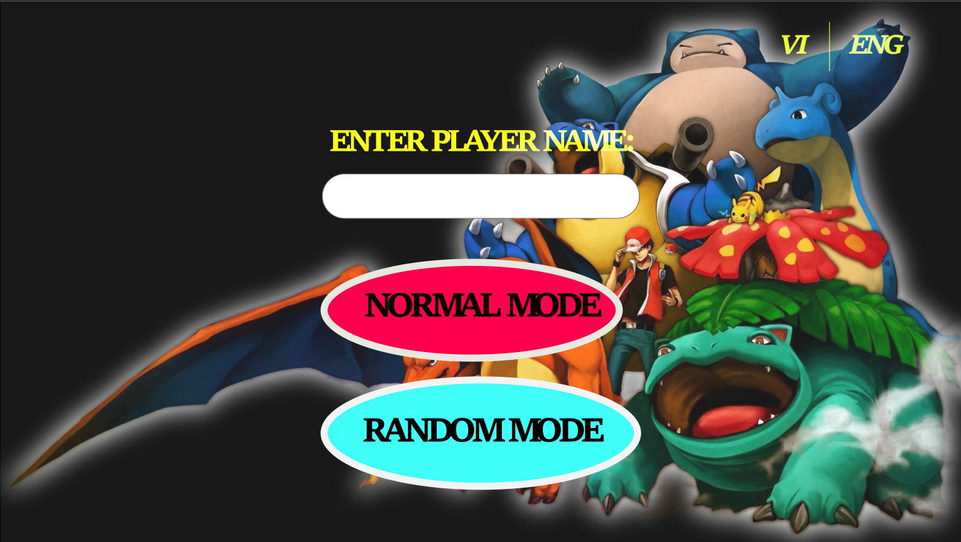

*Main screen of the game*

After players choose the mode and join the same room, they will set up their line up for the battle (In Random Mode, the System will choose the Monsters for them)

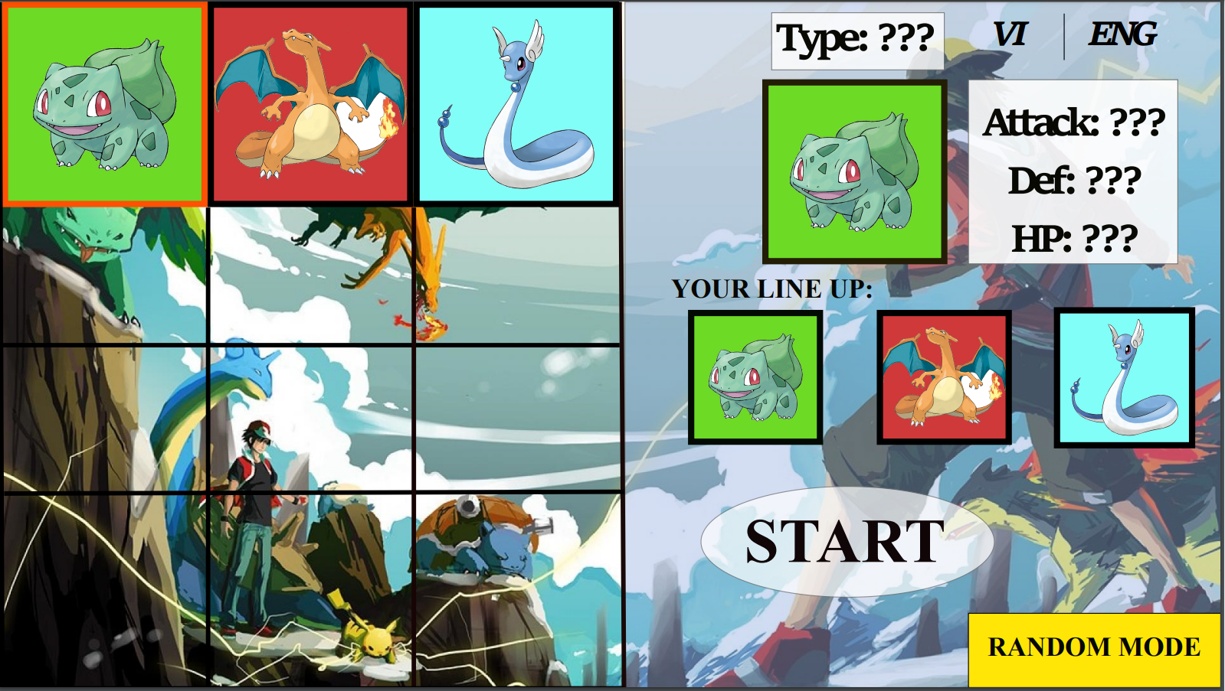

*Random mode Interface*

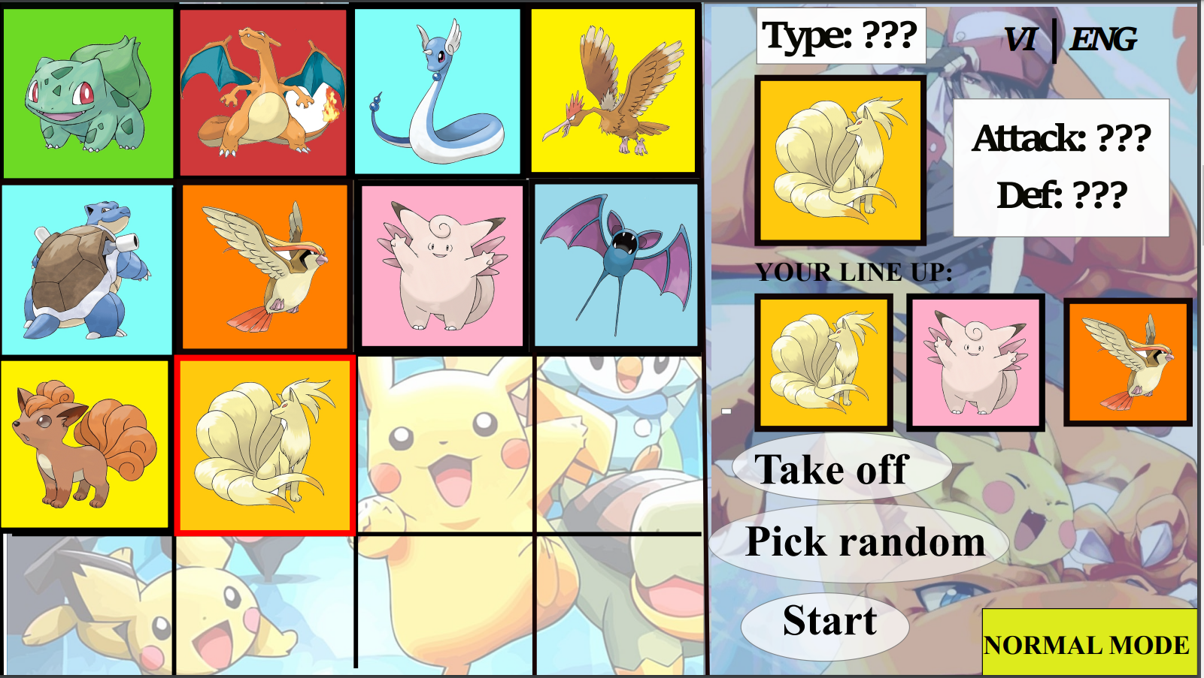

*Normal mode Interface*

After choosing their monsters for the battle, both players will join the Battle Phase. In the Battle Phase, the main actions that players have will be attacking opponent, change the current monster or use the Item like Potion the increase their HP. The Player can also chat with other using the Chat System.

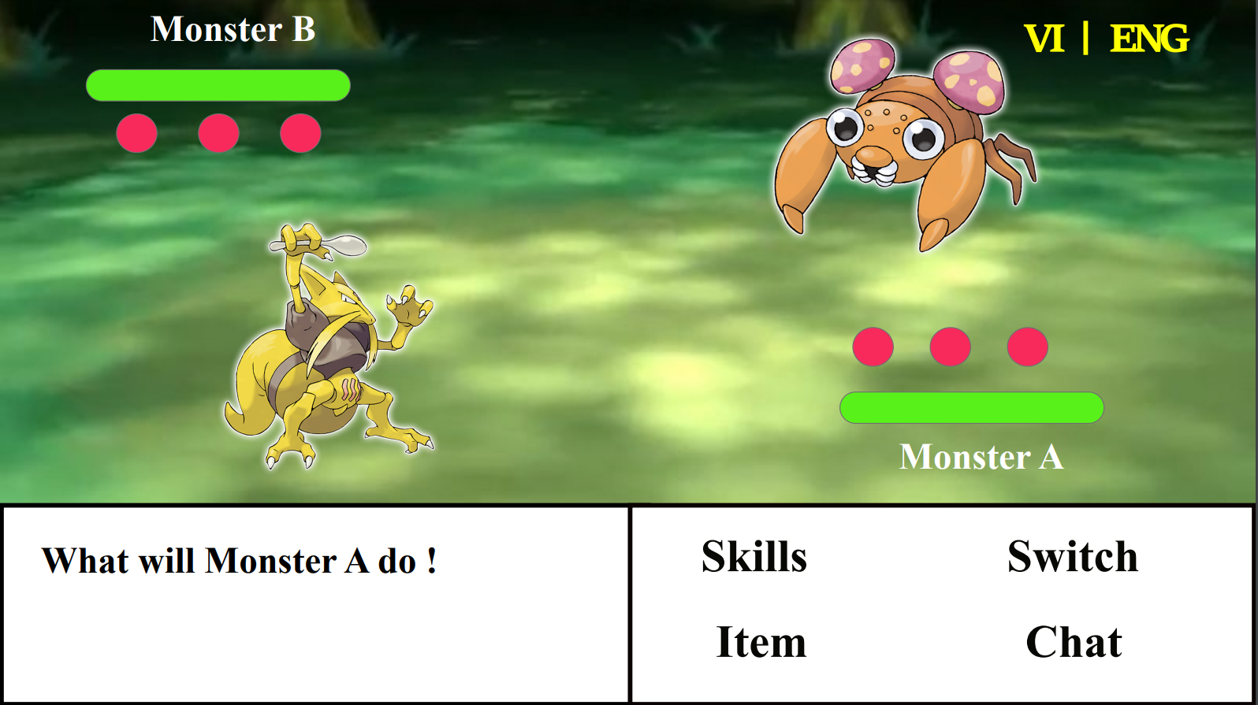

*Battle Phase Interface*

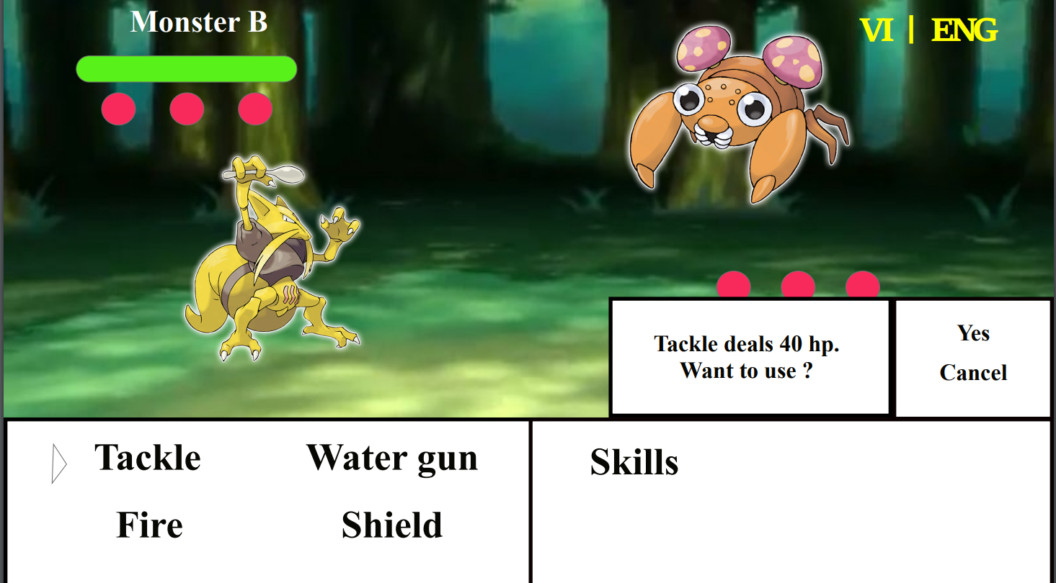

*Using skills Interface*

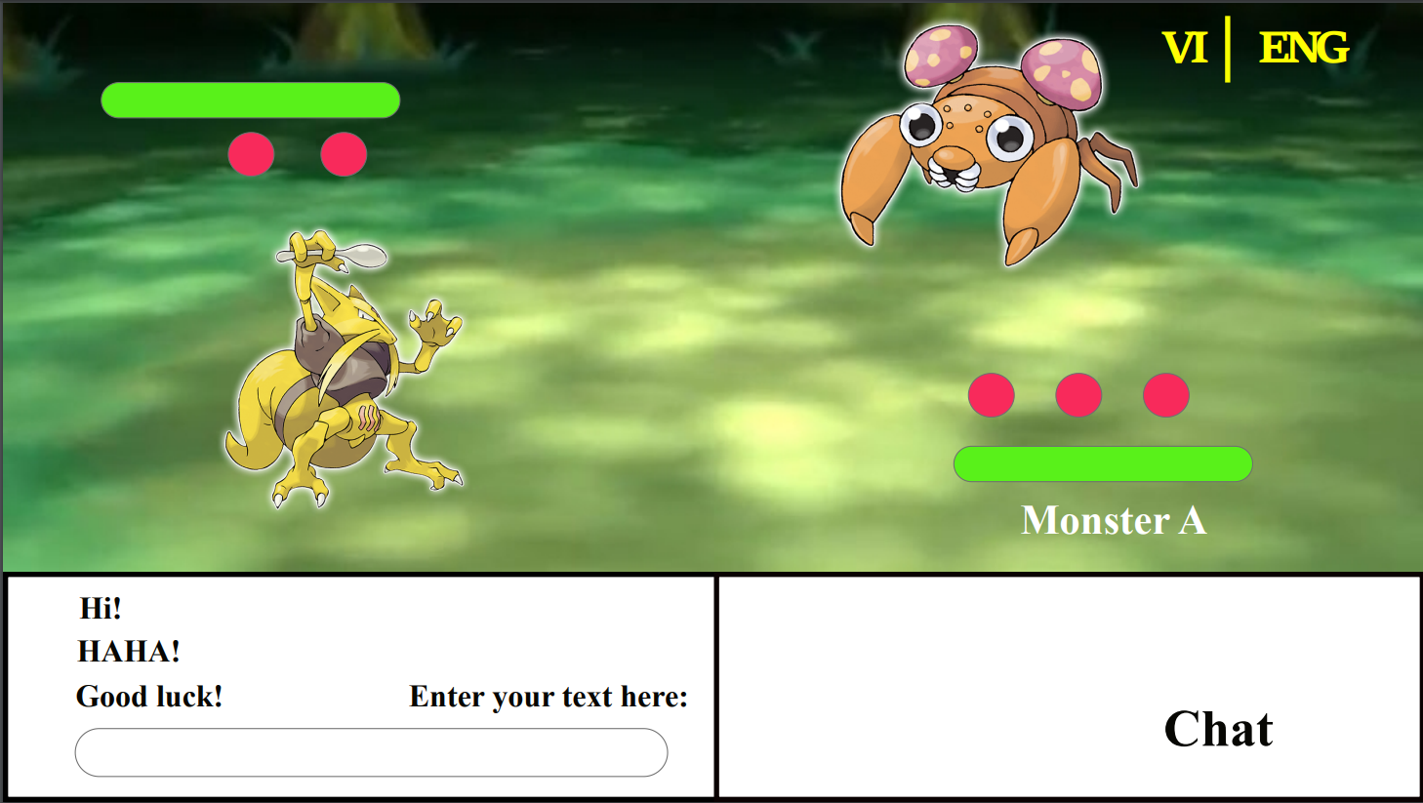

*Chat Interface*

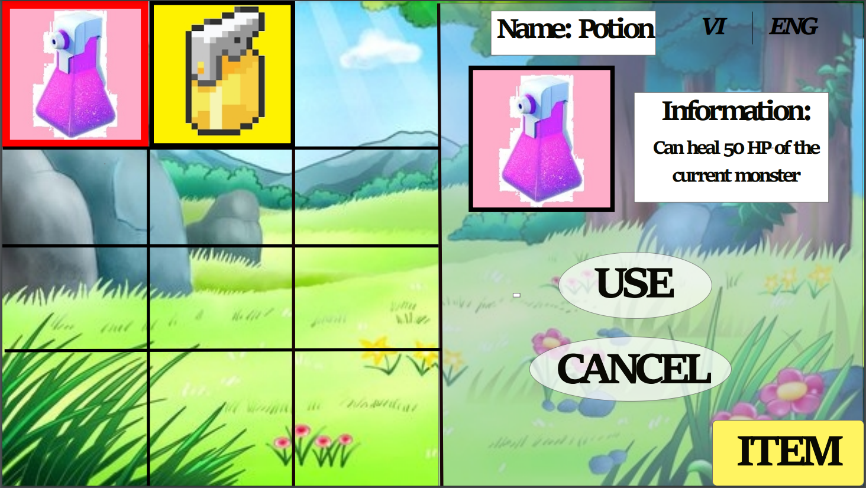

*Using items Interface* 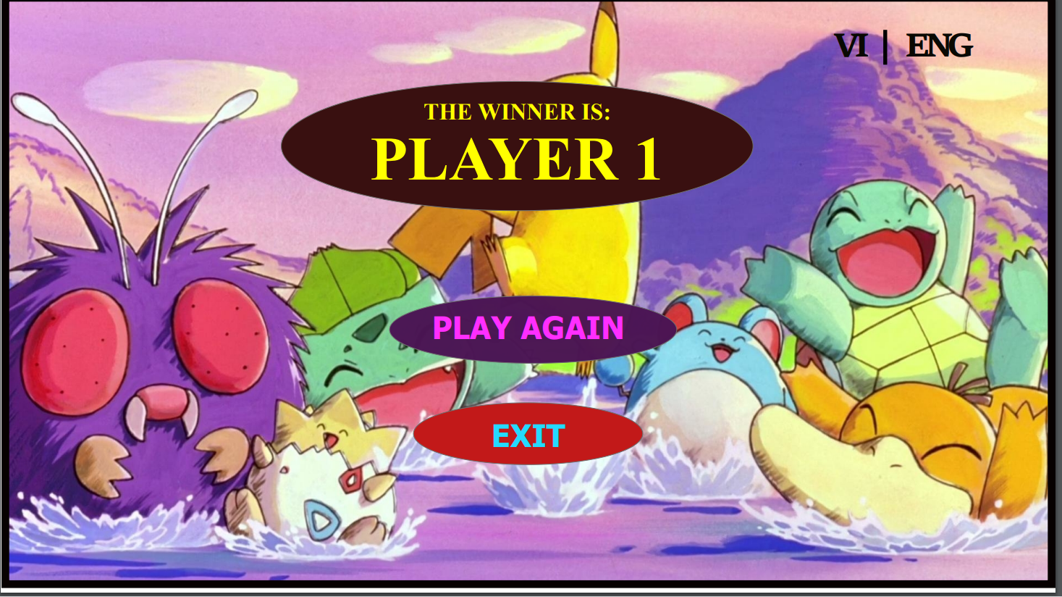

*End-game Interface*

The game will end until all the monsters from one side are all defeated. Then, the system will move to the End Screen and announce the winner, then both players can choose to play again or log out of the game.

1. **Diagrams**

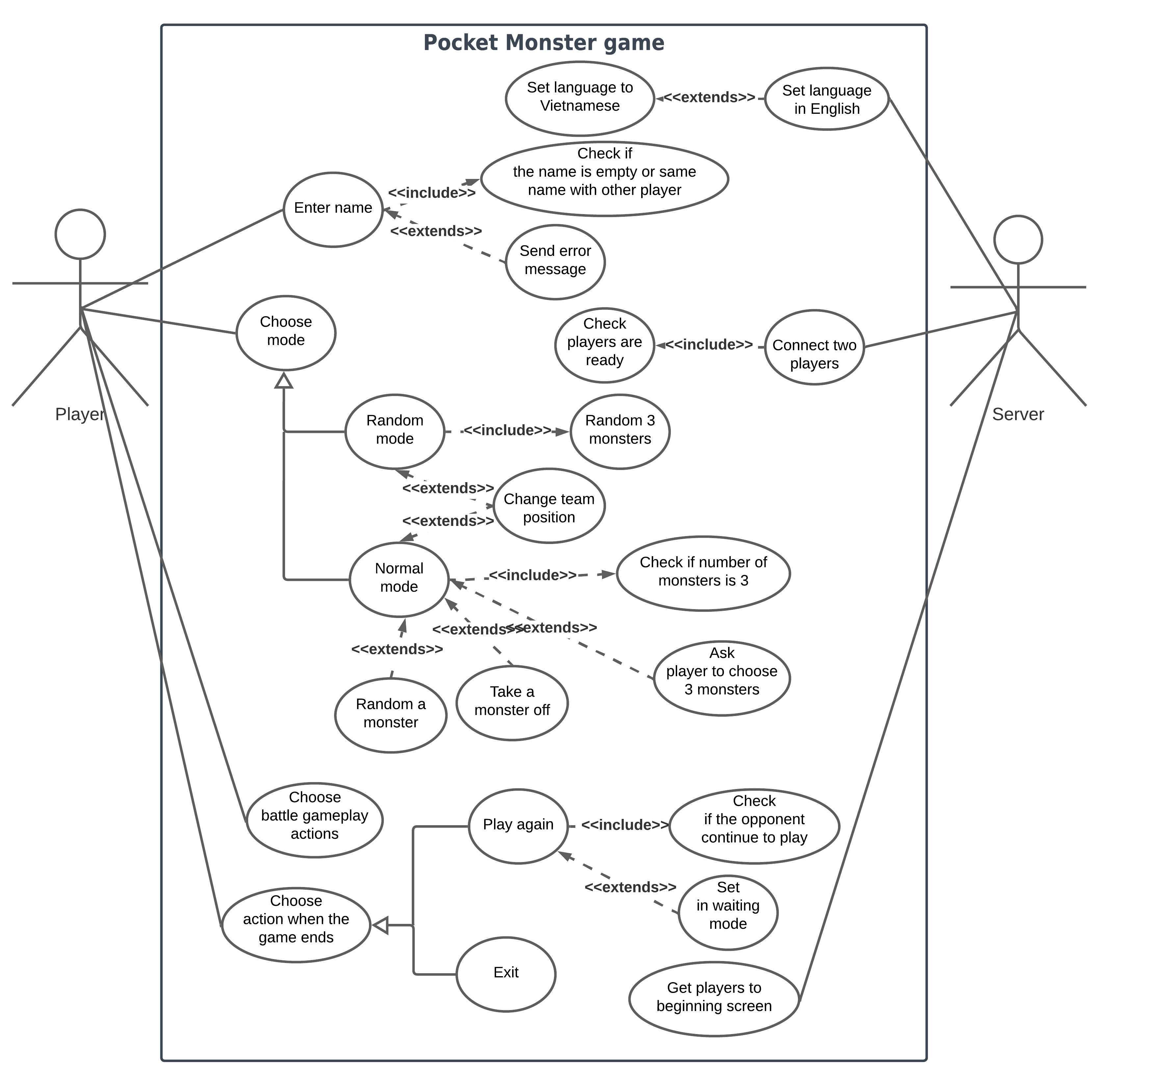

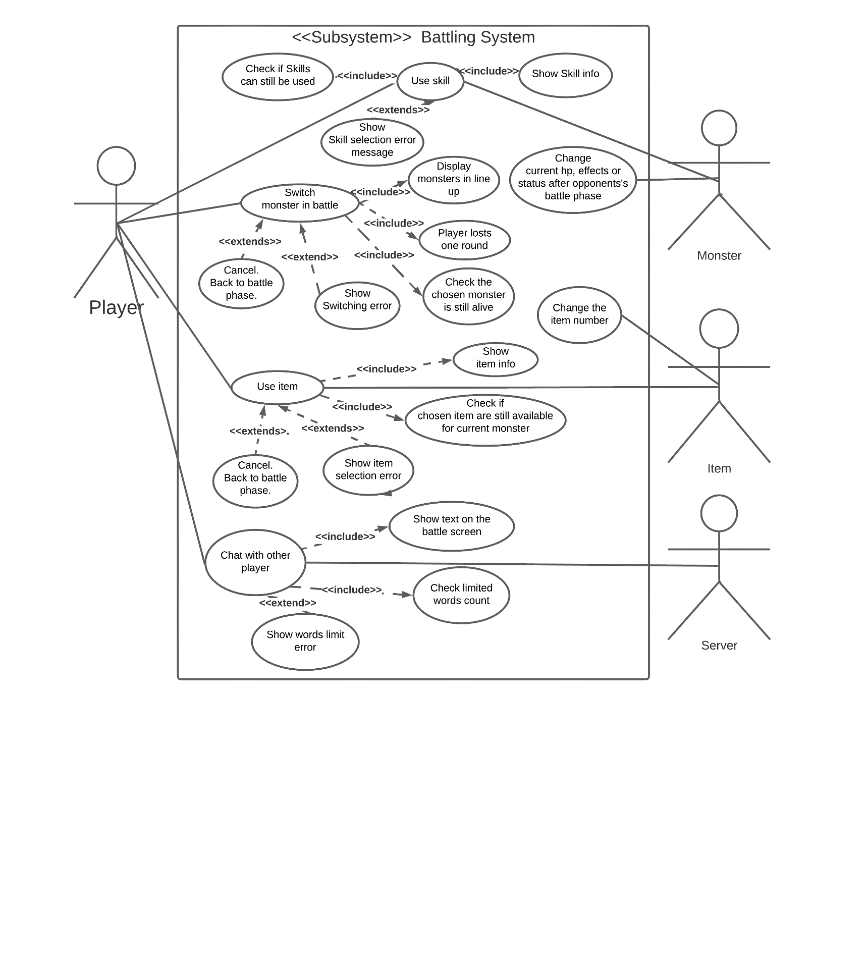

*Use-case diagrams*

1. **Tools and Technologies**

Firstly, we need to design the images and wireframes before we start to make the game. We can use Tools like Balsamiq or Adobe XD to sketch the screens of the game. And I plan to build the project using Java language so I will be coding on IDEA IntelliJ. To build the User Interface, I will have the library JavaFX SDK to make the components of the interface. And during the project, the team will use the Git Hub to save the project, work with each other and help share the progress of each member.

1. **Skills Required**

The game is created using Java, so the skills needed are Java programming language and Object-Oriented Programming. The developers also must know how to work with tools like IDEA IntelliJ and Git Hub. The project has different screens, so the project needs a member with good designing skills and a Front-end coder. On the other hand, the project is based on a game series so all the members should have a brief knowledge of the original version. And finally, soft skills like teamwork, brainstorming, or problem solving will be used during conducting the project.

1. **Outcome**

The ultimate attention of making the project is to satisfy the hobby and express the love for the famous Pokémon game series. After the game is finished, it will create a small playground for people with the same hobby all over the world to enjoy the game not in a traditional way but a totally new way. If the project gets some fame, the team members can get attention from the recruiters and the developer community so their careers can be better in the future. If the project gets successful, the game can be put on the marketplace to earn some profit for the team.

1. **Feedback**

**Le Thanh Tai**

After couple weeks of working together, though our team met some troubles during the progress, but everything turns fine after all. Especially in this semester, I have one project-based course called Android Development which takes a lot of time and efforts of me in these weeks. But my other teammates have support me a lot with this project. I have gained a lot of experiences from this work, not only on teamwork and communicating skills but also report writing skills and how to work on a project.

**Nguyen Tan Thinh**

After working together for some time now, I do have some experience I want to share. During the first few weeks, because we are new to each other so not a lot of communication was going around the group, for this reason not much progress was made. However, when we started to interact with each other, it went very well, everyone worked rather quickly and everyone is nice. Since this is my first time working in a group with only new people, this has helped me improve my communication skills and gain new experiences of working with a new group.

**Doan Chanh Thong**

Working with the team up to the current stage, I feel grateful and fortunate to be a part of this collective. At the beginning stage, we were reluctant and felt strange to talk. It has been a long time since everyone worked online switched to offline; however, the awkwardness disappeared when we communicated and initiated the assignment. Everyone is open-hearted, respectfully listens to others' ideas, and tries their best to complete the assigned task. Though I had personal issues to solve and prolonged our submission plan, the team and I constantly questioned what others had done to ensure everyone benefited and solved any uprising problems. In the meantime, we manage to complete the assignment and have spare time to fix any new obstacles before the deadline.

**Cao Ngoc Son**

After working together with other members of the group, I can conclude that we are working well together. There was not much communication between us for the first few weeks, but it all changed when we started working together for the last few weeks before the assignment 2 deadline. Everyone is helpful to each other, finishes their work without any problems and always welcomes feedback from each other. Since I was busy with 2 other project deadlines that are due prior to this week, I did not do as much work as other group members and left most of them to the last week. Despite that, my group members are very understanding of my situation and always ready to help me. My procrastination might have created some inconvenience for our project progress, but other group members helped me in putting together our assignment 2 successfully. I will take this something to reflect on in other to improve for the next deadline.

1. **References**

[1] C. Zhang and Y. Lu, “Study on artificial intelligence: The state of the art and future prospects,” *J. Ind. Inf. Integr.*, vol. 23, no. 100224, p. 100224, 2021. [Online]. Available:

<https://doi.org/10.1016/j.jii.2021.100224.> [Accessed: Dec. 17, 2021].

[2] “5 ways artificial intelligence will change the world by 2050,” *USC News*, 04-Dec-2017. [Online]. Available: https://news.usc.edu/trojan-family/five-ways-ai-will-change-the-world-by-2050/. [Accessed: 17-Dec-2021].

[3] Builtin.com. 2021. *What is Artificial Intelligence? How Does AI Work? | Built In*. [online] Available at: <https://builtin.com/artificial-intelligence> [Accessed 17 December 2021].

[4] “What is Artificial Intelligence (AI)?,” *Ibm.com*. [Online]. Available: https://www.ibm.com/topics/artificial-intelligence. [Accessed: 17-Dec-2021].

[5] Norvig, P., & Russell, S. (2021). *Artificial Intelligence: A Modern Approach, Global Edition* (4th ed.). Pearson. [Accessed: Dec. 17, 2021].

[6] “Understanding the four types of artificial intelligence,” *GovTech*, 14-Nov-2016. [Online]. Available: https://www.govtech.com/computing/understanding-the-four-types-of-artificial-intelligence.html. [Accessed: 17-Dec-2021].

[7] E. Burns, N. Laskowski, and L. Tucci, “What is Artificial Intelligence (AI)? - AI Definition and How it Works,” *SearchEnterpriseAI*, 09-Aug-2021. [Online]. Available: https://www.techtarget.com/searchenterpriseai/definition/AI-Artificial-Intelligence. [Accessed: 17-Dec-2021].

[8] B. Mondal, “Artificial intelligence: State of the art,” in *Intelligent Systems Reference Library*, Cham: Springer International Publishing, 2020, pp. 389–425.

<https://www.thinkopen.it/en/project/artificial-intelligence-state-of-the-art/> [Accessed: Dec. 17, 2021].

[9] “What is the impact of Artificial Intelligence (AI) on society?,” *Bernard Marr*, 13-Jul-2021. [Online]. Available: https://bernardmarr.com/what-is-the-impact-of-artificial-intelligence-ai-on-society/. [Accessed: 18-Dec-2021].

[10] “What Is The Impact Of Artificial Intelligence (AI) On Society?,” *Hyperight*, 11-Mar-2021. [Online]. Available: https://hyperight.com/what-is-the-impact-of-artificial-intelligence-ai-on-society/. [Accessed: 18-Dec-2021].

[11] J. Cattell, S. Chilukuri, and M. Levy, “How big data can revolutionize pharmaceutical R&D,” *Mckinsey.com*, 24-Jul-2015. [Online]. Available: https://www.mckinsey.com/industries/life-sciences/our-insights/how-big-data-can-revolutionize-pharmaceutical-r-and-d. [Accessed: 18-Dec-2021].

[12] *Accenture.com*. [Online]. Available: https://www.accenture.com/us-en/insights/artificial-intelligence-summary-index. [Accessed: 18-Dec-2021].

[13] PricewaterhouseCoopers, “How will automation impact jobs,” *PwC*. [Online]. Available: https://www.pwc.co.uk/services/economics/insights/the-impact-of-automation-on-jobs.html. [Accessed: 18-Dec-2021].

[14] “What is an Autonomous Car? – How Self-Driving Cars Work | Synopsys”, *Synopsys.com*, n.d. [Online]. Available: <https://www.synopsys.com/automotive/what-is-autonomous-car.html>. [Accessed: Dec. 15, 2021].

[15] “Autopilot”, *Tesla.com*, n.d. [Online]. Available: <https://www.tesla.com/autopilot>. [Accessed: Dec. 17, 2021].

[16] “Artificial Intelligence & Autopilot”, *Tesla*, n.d. [Online]. Available: <https://www.tesla.com/AI>. [Accessed: Dec. 17, 2021].

[17] Polly, “6 Ways Autonomous Vehicles Will Impact Life As We Know It”, *Robotics & Automation News*, Jun. 22, 2020. [Online]. Available: <https://roboticsandautomationnews.com/2020/06/22/6-ways-autonomous-vehicles-will-impact-life-as-we-know-it/33326/>. [Accessed: Dec. 16, 2021].

[18] “Global status report on road safety 2018”, *Who.int*, Jun. 17, 2018. [Online]. Available: <https://www.who.int/publications/i/item/9789241565684>. [Accessed: Dec. 16, 2021].

[19] “Occupational Outlook Handbook”, *U.S. Bureau of Labor Statistics*, Sep. 13, 2021. [Online]. Available: <https://www.bls.gov/ooh/transportation-and-material-moving/passenger-vehicle-drivers.htm#tab-1>. [Accessed: Dec. 16, 2021].

[20] "What Is Cloud Computing? A Beginner’s Guide | Microsoft Azure", *Azure.microsoft.com*. [Online]. Available: https://azure.microsoft.com/en-us/overview/what-is-cloud-computing/#benefits. [Accessed: 16- Dec- 2021].

[21] "The history of cloud computing", *scality*, 2021. [Online]. Available: https://www.scality.com/solved/the-history-of-cloud-computing/. [Accessed: 16- Dec- 2021].

[22] "Public vs Private vs Hybrid: Cloud Differences Explained", *BMC Blogs*, 2021. [Online]. Available: https://www.bmc.com/blogs/public-private-hybrid-cloud/. [Accessed: 16- Dec- 2021].

[23] C. Market, "Cloud Computing Market Size, Share and Global Market Forecast to 2026 | COVID-19 Impact Analysis | MarketsandMarkets", *Marketsandmarkets.com*, 2021. [Online]. Available: https://www.marketsandmarkets.com/Market-Reports/cloud-computing-market-234.html. [Accessed: 16- Dec- 2021].

[24] "26 Cloud Computing Statistics, Facts & Trends for 2021", *Cloudwards*, 2021. [Online]. Available: https://www.cloudwards.net/cloud-computing-statistics/#Sources. [Accessed: 16- Dec- 2021].

[25] "Uses of cloud computing in everyday life", *Koofr blog*, 2021. [Online]. Available: https://koofr.eu/blog/posts/uses-of-cloud-computing-in-everyday-life. [Accessed: 16- Dec- 2021].

[26] J. Steward, "19+ Fascinating Cloud Computing Statistics & Facts for 2022", *Findstack*, 2021. [Online]. Available: https://findstack.com/cloud-computing-statistics/. [Accessed: 16- Dec- 2021].

[27] "26 Cloud Computing Statistics, Facts & Trends for 2021", *Cloudwards*, 2021. [Online]. Available: https://www.cloudwards.net/cloud-computing-statistics/#recent-trends-in-cloud-computing. [Accessed: 16- Dec- 2021].

[28] "What is Cloud Computing", *Amazon Web Services, Inc.*, 2021. [Online]. Available: https://aws.amazon.com/what-is-cloud-computing/. [Accessed: 16- Dec- 2021].

[29]2021. [Online]. Available: https://canalys.com/newsroom/canalys-china-cloud-services-market-Q4-2020. [Accessed: 16- Dec- 2021].

[30] A. Market, "Artificial Intelligence (AI) Market worth $309.6 billion by 2026", *Marketsandmarkets.com*, 2021. [Online]. Available: https://www.marketsandmarkets.com/PressReleases/artificial-intelligence.asp. [Accessed: 16- Dec- 2021].

[31] B. Lang, "New Google Stadia Job Listings Suggest VR Cloud-gaming Ambitions", *Road to VR*, 2021. [Online]. Available: https://www.roadtovr.com/google-stadia-vr-job-listings/. [Accessed: 16- Dec- 2021].

[32] "Video Streaming Market Size & Share Report, 2021-2028", *Grandviewresearch.com*, 2021. [Online]. Available: https://www.grandviewresearch.com/industry-analysis/video-streaming-market. [Accessed: 16- Dec- 2021].

[33] "Global Cloud Gaming Market Size, Share Report, 2021-2027", *Grandviewresearch.com*, 2021. [Online]. Available: https://www.grandviewresearch.com/industry-analysis/cloud-gaming-market. [Accessed: 16- Dec- 2021].

[34] "Enterprise cloud computing challenges 2020 | Statista", *Statista*, 2021. [Online]. Available: https://www.statista.com/statistics/511283/worldwide-survey-cloud-computing-risks/. [Accessed: 16- Dec- 2021].

[35] "2021 State of the Cloud Report | Flexera", *Info.flexera.com*, 2021. [Online]. Available: https://info.flexera.com/CM-REPORT-State-of-the-Cloud. [Accessed: 16- Dec- 2021].

[36] "1 In 3 Remote Workers May Quit If Required To Return To The Office Full Time, Robert Half Survey Finds", *Rh-us.mediaroom.com*, 2021. [Online]. Available: https://rh-us.mediaroom.com/2021-04-06-1-In-3-Remote-Workers-May-Quit-If-Required-To-Return-To-The-Office-Full-Time-Robert-Half-Survey-Finds. [Accessed: 16- Dec- 2021].

**(Son)**

[37] A. Hayes, “Blockchain explained,” *Investopedia*, 08-Dec-2021. [Online]. Available: <https://www.investopedia.com/terms/b/blockchain.asp>. [Accessed: 17-Dec-2021].

[38] A. Levy, “15 applications for Blockchain technology,” *The Motley Fool*, 25-Oct-2021. [Online]. Available: <https://www.fool.com/investing/stock-market/market-sectors/financials/blockchain-stocks/blockchain-applications/>. [Accessed: 17-Dec-2021].

[39] C. B. -, C. Brett, S. B. -, I. M. -, R. E. -, and C. B. -, “Blockchain disadvantages: 10 possible reasons not to enthuse,” *Enterprise Times*, 11-Oct-2018. [Online]. Available: <https://www.enterprisetimes.co.uk/2018/10/15/blockchain-disadvantages-10-possible-reasons-not-to-enthuse/>. [Accessed: 17-Dec-2021].

[40] D. Walsh, “What are cryptocurrencies and how do you use them?,” *euronews*, 08-Jun-2021. [Online]. Available: <https://www.euronews.com/next/2021/06/08/what-are-cryptocurrencies-and-how-do-you-use-them-a-beginner-s-guide-to-cryptocurrencies>. [Accessed: 17-Dec-2021].

[41] PricewaterhouseCoopers, “Making sense of bitcoin, cryptocurrency and Blockchain,” *PwC*. [Online]. Available: <https://www.pwc.com/us/en/industries/financial-services/fintech/bitcoin-blockchain-cryptocurrency.html>. [Accessed: 17-Dec-2021].

[42] S. Boukhalfa, “What are the disadvantages of cryptocurrencies? - prescouter - custom intelligence from a global network of experts,” *PreScouter*, 19-Dec-2019. [Online]. Available: <https://www.prescouter.com/2019/11/disadvantages-of-cryptocurrencies/>. [Accessed: 17-Dec-2021].

[43] S. Daley, “34 blockchain applications and real-world use cases disrupting the status quo,” *Built In*. [Online]. Available: <https://builtin.com/blockchain/blockchain-applications>. [Accessed: 17-Dec-2021].

[44] “What is blockchain?,” *Blockchain Explained: What is blockchain? | Euromoney Learning*. [Online]. Available: <https://www.euromoney.com/learning/blockchain-explained/what-is-blockchain>. [Accessed: 17-Dec-2021].